**Contents:-**

1-Why LTE Required.

2- Use of LTE/Benefits of LTE

3-LTE Call Flow & Architecture in Details.

4- CSFB

5- SRVCC

6- SIP/IMS

7- Hand Over & Types Of Handover in LTE

8- Channel

9- Types of Events

10- MIMO Technique

11- OFDMA & SC-FDMA

12- Modulation Scheme

13-SRB

14- MIB/SIB

15-Latency

Layer3

1-RACH/PRACH

a-Why Rach /Required & Fuctionality of RACH

b-When RACH Process Occurs..

c)RA-RNTI/TC-RNTI/C-RNTI

2-RRCConnection Establishment

a)- RRC Connection Request

b)- RRC Connection SetUp

c)- RRC Connection Setup Complete

**Layer2**

1. Fuctionality of Mac/RRC/PDCP
2. Logical Channel Priority (LCP)& Prioritization Bit rate(PBR)
3. Scheduling
4. SR
5. Drx
6. PHR(Power Head Room)
7. TTI
8. BSR
9. PDU
10. HARQ
11. RLC Layer
12. PDCP Layer

**LTE (*Long Term Evolution)***

LTE evolved from an earlier 3GPP system known as the Universal Mobile Telecommunication System (UMTS), which in turn evolved from the Global System for Mobile Communications (GSM).

The main goal of LTE is to provide a high data rate, low latency and packet optimized radio access technology supporting flexible bandwidth deployments. Same time its network architecture has been designed with the goal to support packet-switched traffic with seamless mobility and great quality of service.

## Facts about LTE

* LTE is the successor technology not only of UMTS but also of CDMA 2000.
* LTE is important because it will bring up to 50 times performance improvement and much better spectral efficiency to cellular networks.
* LTE introduced to get higher data rates, 300Mbps peak downlink and 75 Mbps peak uplink. In a 20MHz carrier, data rates beyond 300Mbps can be achieved under very good signal conditions.
* LTE is an ideal technology to support high date rates for the services such as voice over IP (VOIP), streaming multimedia, videoconferencing or even a high-speed cellular modem.
* LTE uses both Time Division Duplex (TDD) and Frequency Division Duplex (FDD) mode. In FDD uplink and downlink transmission used different frequency, while in TDD both uplink and downlink use the same carrier and are separated in Time.
* LTE supports flexible carrier bandwidths, from 1.4 MHz up to 20 MHz as well as both FDD and TDD. LTE designed with a scalable carrier bandwidth from 1.4 MHz up to 20 MHz which bandwidth is used depends on the frequency band and the amount of spectrum available with a network operator.
* All LTE devices have to support (MIMO) Multiple Input Multiple Output transmissions, which allow the base station to transmit several data streams over the same carrier simultaneously.
* All interfaces between network nodes in LTE are now IP based, including the backhaul connection to the radio base stations. This is great simplification compared to earlier technologies that were initially based on E1/T1, ATM and frame relay links, with most of them being narrowband and expensive.
* Quality of Service (QoS) mechanism have been standardized on all interfaces to ensure that the requirement of voice calls for a constant delay and bandwidth, can still be met when capacity limits are reached.
* Works with GSM/EDGE/UMTS systems utilizing existing 2G and 3G spectrum and new spectrum. Supports hand-over and roaming to existing mobile networks.

## Advantages of LTE

* **High throughput:** High data rates can be achieved in both downlink as well as uplink. This causes high throughput.
* **Low latency:** Time required to connect to the network is in range of a few hundred milliseconds and power saving states can now be entered and exited very quickly.
* **FDD and TDD in the same platform:** Frequency Division Duplex (FDD) and Time Division Duplex (TDD), both schemes can be used on same platform.
* **Superior end-user experience:** Optimized signaling for connection establishment and other air interface and mobility management procedures have further improved the user experience. Reduced latency (to 10 ms) for better user experience.
* **Seamless Connection:** LTE will also support seamless connection to existing networks such as GSM, CDMA and WCDMA.
* **Plug and play:** The user does not have to manually install drivers for the device. Instead system automatically recognizes the device, loads new drivers for the hardware if needed, and begins to work with the newly connected device.
* **Simple architecture:** Because of Simple architecture low operating expenditure (OPEX).

## LTE - QoS

LTE architecture supports **hard QoS,** with end-to-end quality of service and guaranteed bit rate (GBR) for radio bearers. Just as Ethernet and the internet have different types of QoS, for example, various levels of QoS can be applied to LTE traffic for different applications. Because the LTE MAC is fully scheduled, QoS is a natural fit.

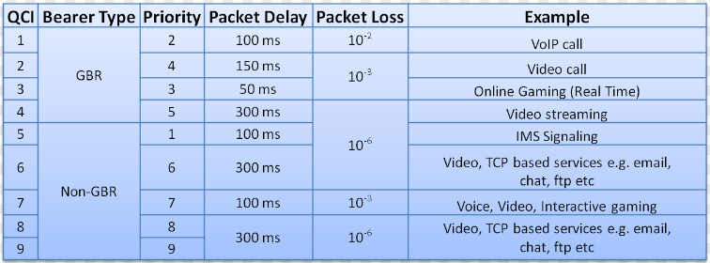

Evolved Packet System (EPS) bearers provide one-to-one correspondence with RLC radio bearers and provide support for Traffic Flow Templates (TFT). There are four types of EPS bearers:

* **GBR Bearer** resources permanently allocated by admission control
* **Non-GBR Bearer** no admission control
* **Dedicated Bearer** associated with specific TFT (GBR or non-GBR)
* **Default Bearer** Non GBR, **catch-all** for unassigned traffic

**LTE Architecture:-**

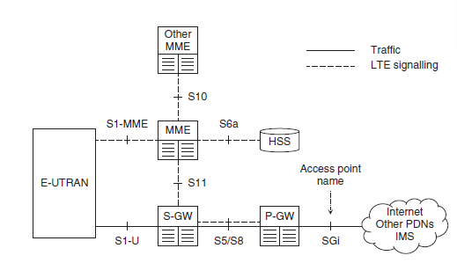

### Mobility Management Entity (MME):

### The MME is a control entity. It is responsible for all the control plane operations. All the NAS signaling originates at UE and terminates in MME. MME is also responsible for tracking area list management, selection of PGW/SGW and also selection of other MME during handovers. MME is also responsible for SGSN (Serving GPRS Support Node) selection during LTE to 2G/3G handovers. The UE is also authenticated by MME.MME is also responsible for bearer management functions including establishment of dedicated bearers for all signaling traffic flow.

### Serving Gateway (SGW):

**Serving gateway** terminates the interface towards EUTRAN. For each UE there is a single Serving GW associated with EPS at a given point of time. SGW acts as a local mobility entity for inter eNB handovers. It also acts a mobility anchor for inter 3GPP mobility. SGW is responsible for packet routing and forwarding, buffering the downlink packets. As eNB is responsible for uplink packet marking, SGW is responsible for downlink packet marking.

### PDN Gateway (PGW):

**PGW** terminates SGi interface towards the PDN. PGW is responsible for all the IP packet based operations such as deep packet inspection, UE IP address allocation, Transport level packet marking in uplink and downlink, accounting etc. PGW contacts PCRF to determine the QoS for bearers. It is also responsible for UL and DL rate enforcement.

### Home Subscriber Server (HSS):

The HSS is a central database that contains user-related and subscription-related information. The functions of the HSS include functionalities such as mobility management, call and session establishment support, user authentication and access authorization. It also holds information about the PDNs to which the user can connect. In addition the HSS holds dynamic information such as the identity of the MME to which the user is currently attached or registered. The HSS may also integrate the

authentication center (AUC), which generates the vectors for authentication and security keys.

### Policy Control and Charging Rules Function (PCRF):

The**PCRF**is responsible for policy control decision-making as well as for controlling the flow-based charging functionalities in the Policy Control Enforcement Function (PCEF), which resides in the P-GW. The PCRF provides the QoS authorization (QoS class identifier [QCI] and bit rates) that decides how a certain data flow will be treated in the PCEF and ensures that this is in accordance with the user's subscription profile.

**LTE Call Flow:-**



CSFB,VoLTE/IMS/SIP & SRVCC in LTE



**CSFB Call Flow:-**



**Handover Procedures in LTE**

Handover procedures are a key function of LTE eNBs. They are intended to reduce interruption time compared to the circuit-switched handover process in 2G networks. Thoroughly evaluating the performance of LTE eNBs requires testing multiple handover procedures

### Types of Handover in LTE network

* **Intra-LTE Handover:** In this case source and target cells are part of the same LTE network.
* **Inter-LTE Handover:**Handover happens towards other LTE nodes. (Inter-MME and Inter-SGW)
* **Inter-RAT:** Handover between different radio technologies. For example handover from LTE to WCDMA.

### Intra-LTE Handovers

There are different use cases for Intra-LTE handovers. There are primarily three types of Intra-LTE handover can be possible

#### Intra-MME/SGW: Handover using X2 Interface

X2 is the interface between two eNodeBs, serving eNodeB and target eNodeB in this case. When X2 interface is present then handover is completed without EPC (Evolved Packet Core) involvement. The release of the resources at source eNodeB is triggered by target eNodeB.

#### Intra-MME/SGW: Handover using S1 Interface

In case when X2 interface is not available and source eNodeB and target eNodeB are part of same MME/SGW then handover is carried out through S1 interface. The S-eNB initiates the handover by sending a Handover required message over the S1-MME reference point. The EPC does not change the decisions taken by the S-eNB.

### Inter-LTE Handovers:-

#### Inter-MME Handover

In Inter-MME handover two MME are involved in handover, source MME and target MME. The source MME (S-MME) is in charge of the source eNodeB and target MME (T-MME) is in charge of target eNodeB.

Inter-MME handover occurs when UE moves between two different MMEs but connected to same SGW.

#### Inter-MME/SGW Handover

This is same as Inter-MME but only difference is that here UE need to move from one MME/SGW to another MME/SGW. Source eNodeB is part of one MME/SGW and target eNodeB is in another MME/SGW.

### Inter-RAT Handover

#### Handover from eUTRAN to UTRAN

In case of handover between eUTRAN to UTRAN, the source eNodeB is connected to source MME and SGW and target RNC is connected to Target SGSN and Target SGW.

First the required resources are reserved in UTRAN system and the handover is carried out.

**Channel:-**

### LTE Logical,Transport and Physical channels:-

one carrying control information and the other carrying traffic informtion. These gets mapped to transport channels as depicted in the figure. The left side is downlink channel mapping and right side is uplink channel mapping.

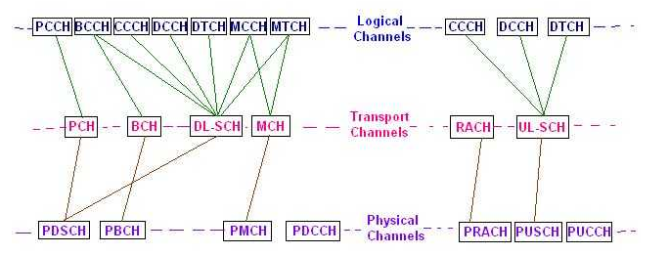

There are several forms of data that need to be sent over the LTE radio interface. LTE uses a series of data channels to provide effective management of the data: physical, logical and transport channels are used.

**LTE Physical Channel**

* ***Downlink:***

***Physical Broadcast Channel (PBCH):***   This physical channel carries system information for UEs requiring to access the network. It only carries what is termed Master Information Block, MIB, messages. The modulation scheme is always QPSK and the information bits are coded and rate matched - the bits are then scrambled using a scrambling sequence specific to the cell to prevent confusion with data from other cells.  
The MIB message on the PBCH is mapped onto the central 72 subcarriers or six central resource blocks regardless of the overall system bandwidth. A PBCH message is repeated every 40 ms, i.e. one TTI of PBCH includes four radio frames.  
  
The PBCH transmissions has 14 information bits, 10 spare bits, and 16 CRC bits.

***Physical Control Format Indicator Channel (PCFICH) :***   As the name implies the PCFICH informs the UE about the format of the signal being received. It indicates the number of OFDM symbols used for the PDCCHs, whether 1, 2, or 3. The information within the PCFICH is essential because the UE does not have prior information about the size of the control region.  
A PCFICH is transmitted on the first symbol of every sub-frame and carries a Control Format Indicator, CFI, field. The CFI contains a 32 bit code word that represents 1, 2, or 3. CFI 4 is reserved for possible future use.  
The PCFICH uses 32,2 block coding which results in a 1/16 coding rate, and it always uses QPSK modulation to ensure robust reception.

***Physical Downlink Control Channel (PDCCH) :***   The main purpose of this physical channel is to carry mainly scheduling information of different types:

* + - Downlink resource scheduling
    - Uplink power control instructions
    - Uplink resource grant
    - Indication for paging or system information

The PDCCH contains a message known as the Downlink Control Information, DCI which carries the control information for a particular UE or group of UEs. The DCI format has several different types which are defined with different sizes. The different format types include: Type 0, 1, 1A, 1B, 1C, 1D, 2, 2A, 2B, 2C, 3, 3A, and 4.

***Physical Hybrid ARQ Indicator Channel (PHICH) :***   As the name implies, this channel is used to report the Hybrid ARQ status. It carries the HARQ ACK/NACK signal indicating whether a transport block has been correctly received. The HARQ indicator is 1 bit long - "0" indicates ACK, and "1" indicates NACK.  
The PHICH is transmitted within the control region of the subframe and is typically only transmitted within the first symbol. If the radio link is poor, then the PHICH is extended to a number symbols for robustness.

***Uplink:***

***Physical Uplink Control Channel (PUCCH) :***   The Physical Uplink Control Channel, PUCCH provides the various control signalling requirements. There are a number of different PUCCH formats defined to enable the channel to carry the required information in the most efficient format for the particular scenario encountered. It includes the ability to carry SRs, Scheduling Requests.

***Physical Uplink Shared Channel (PUSCH) :***   This physical channel found on the LTE uplink is the Uplink counterpart of PDSCH

***Physical Random Access Channel (PRACH) :***   This uplink physical channel is used for random access functions. This is the only non-synchronised transmission that the UE can make within LTE. The downlink and uplink propagation delays are unknown when PRACH is used and therefore it cannot be synchronised.  
The PRACH instance is made up from two sequences: a cyclic prefix and a guard period. The preamble sequence may be repeated to enable the eNodeB to decode the preamble when link conditions are poor.

**LTE logical channels:-**

The logical channels cover the data carried over the radio interface. The Service Access Point, SAP between MAC sublayer and the RLC sublayer provides the logical channel.

* ***Control channels:*** these LTE control channels carry the control plane information:

***Broadcast Control Channel (BCCH) :***   This control channel provides system information to all mobile terminals connected to the eNodeB.

***Paging Control Channel (PCCH) :***   This control channel is used for paging information when searching a unit on a network.

***Common Control Channel (CCCH) :***   This channel is used for random access information, e.g. for actions including setting up a connection.

***Multicast Control Channel (MCCH) :***   This control channel is used for Information needed for multicast reception.

***Dedicated Control Channel (DCCH) :***   This control channel is used for carrying user-specific control information, e.g. for controlling actions including power control, handover, etc..

***Traffic channels:***These LTE traffic channels carry the user-plane data:

***Dedicated Traffic Channel (DTCH) :***   This traffic channel is used for the transmission of user data.

***Multicast Traffic Channel (MTCH) :***   This channel is used for the transmission of multicast data.

**LTE Transport Channels:-**

The LTE transport channels vary between the uplink and the downlink as each has different requirements and operates in a different manner. Physical layer transport channels offer information transfer to medium access control (MAC) and higher layers.

***Downlink:***

***Broadcast Channel (BCH) :***   The LTE transport channel maps to Broadcast Control Channel (BCCH)

***Downlink Shared Channel (DL-SCH) :***   This transport channel is the main channel for downlink data transfer. It is used by many logical channels.

***Paging Channel (PCH) :***   To convey the PCCH

***Multicast Channel (MCH) :***   This transport channel is used to transmit MCCH information to set up multicast transmissions.

***Uplink:***

***Uplink Shared Channel (UL-SCH) :***   This transport channel is the main channel for uplink data transfer. It is used by many logical channels.

***Random Access Channel (RACH) :***   This is used for random access requirements.

The basic concept of data channels is not new and has been used in previous generations of mobile telecommunications systems. The LTE channels bear many similarities to those of the previous generations, but the channels are tailored to LTE and building on the functionality.

The LTE channels for data transport enable the system to operate efficiently and effectively by ensuring that the data is partitioned and also routed to the required destination as easily as possible.

**LTE MIMO:-**

The use of MIMO technology has been introduced successively over the different releases of the LTE standards.

MIMO has been a cornerstone of the LTE standard, but initially, in releases 8 and 9 multiple transmit antennas on the UE was not supported because in the interested of power reduction, only a single RF power amplifier was assumed to be available.

**LTE MIMO modes**

There are several ways in which MIMO is implemented in LTE. These vary according to the equipment used, the channel function and the equipment involved in the link.

* ***Single antenna:***   This is the form of wireless transmission used on most basic wireless links. A single data stream is transmitted on one antenna and received by one or more antennas. It may also be referred to as SISO: Single In Single Out or SIMO Single In Multiple Out dependent upon the antennas used. SIMO is also called receive diversity.
* ***Transmit diversity:***   This form of LTE MIMO scheme utilises the transmission of the same information stream from multiple antennas. LTE supports two or four for this technique.. The information is coded differently using Space Frequency Block Codes. This mode provides an improvement in signal quality at reception and does not improve the data rate. Accordingly this form of LTE MIMO is used on the Common Channels as well as the Control and Broadcast channels.
* ***Open loop spatial multiplexing:***   This form of MIMO used within the LTE system involves sending two information streams which can be transmitted over two or more antennas. However there is no feedback from the UE although a TRI, Transmit Rank Indicator transmitted from the UE can be used by the base station to determine the number of spatial layers.
* ***Close loop spatial multiplexing :***   This form of LTE MIMO is similar to the open loop version, but as the name indicates it has feedback incorporated to close the loop. A PMI, Pre-coding Matrix Indicator is fed back from the UE to the base station. This enables the transmitter to pre-code the data to optimise the transmission and enable the receiver to more easily separate the different data streams.
* ***Closed loop with pre-coding:***   This is another form of LTE MIMO, but where a single code word is transmitted over a single spatial layer. This can be sued as a fall-back mode for closed loop spatial multiplexing and it may also be associated with beamforming as well.
* ***Multi-User MIMO, MU-MIMO:***   This form of LTE MIMO enables the system to target different spatial streams to different users.
* ***Beam-forming & MIMO:***   This is the most complex of the MIMO modes and it is likely to use linear arrays that will enable the antenna to focus on a particular area. This will reduce interference, and increase capacity as the particular UE will have a beam formed in their particular direction. In this a single code word is transmitted over a single spatial layer. A dedicated reference signal is used for an additional port. The terminal estimates the channel quality from the common reference signals on the antennas.

As the LTE standards progressed, so the numbers of antennas being supported increased. For many mobiles the use of MIMO just resulted in improvements in signal performance, whereas for others it was able to provide real data rate improvements.

**Events:-**

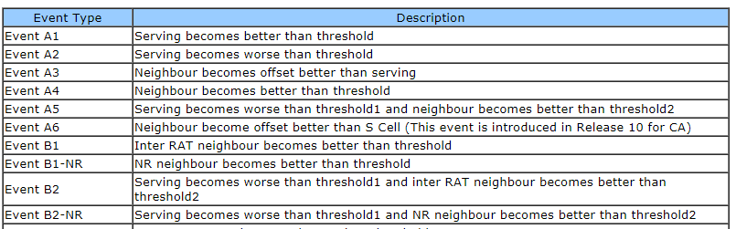

**SC-FDMA& OFDMA(Single Carrier & Orthogonal Frequency Division Multiplexing) :-**

* . SC-FDMA used in UL & OFDMA used in DL.
* OFDMA transmits 4 qpsk symbols in parallel, one data symbol per subcarrier. SC-FDMA transmits qpsk symbols in the series but at 4 time the rate compare to OFDMA. Here qpsk symbol occupy much wider bandwidth about M x 15KHz where M is no. subcarriers
* From the figure it is imperative that OFDMA is multi-carrier system with one data symbol carried over by one subcarrier; while SC-FDMA is a single carrier system where in each qpsk symbol is carried by one much wider bandwidth Subcarrier.
* Though symbol length remains same in both OFDMA and SC-FDMA which is about 66.7µS; SC-FDMA symbol contains more than one sub-symbols which represents qpsk data symbols.
* Parallel multiple data symbol transmission will lead to higher PAPR(Peak to Average Power Ratio) in the OFDMA system. In SC-FDMA, PAPR is same as that of original qpsk data symbols as M qpsk data symbols are transmitted in series at M times rate compare to OFDMA.

**Modulation Scheme:-**

Each symbol represents bits depending on the modulation technique, Each data point represents a different bit pattern.  **LTE**devices use QPSK(2bit/Symbol), 16QAM(4bit/Symbol) and 64QAM (6bit/Symbol)to modulate data and control information.  The eNodeB supports all of these modulation techniques for the Down Link direction. However, 64QAM is optional in the Uplink direction.

**Latency:-** Latency is a time interval between simulation & response/ Time dalay between the cause & the effect of some physical change in system being observed.

Latency in user plane is <5ms & Control Plane is <50ms.

## LTE Signalling Radio Bearer types-SRB0,SRB1,SRB2

## There are three types of SRB in the LTE technology.. •  SRB0 used to transfer RRC messages which use CCCH channel. •  SRB1 used to transfer RRC messages which use DCCH channel. •  SRB2 used to transfer RRC messages which use DCCH channel and encapsulates a NAS message.

SRB1 is also used to encapsulate NAS message if SRB2 has not been configured.   
SRB2 has lower priority then SRB1 and it is always configured after security activation.  
SRB0 uses transparent mode RLC while SRB1 and SRB2 use acknowledged mode RLC.

**MIB(Master Information Block)& SIB(System information Block):**

MIB---BCCH-BCH-PBCH(24bits)

3bits-System bandwidths

3bits-PHICH information(1bit to indicate normal or extended PHICH & 2bit to indicate PHICH Ng Value)

8 bits- System Frame Number(SFN)

10 bits-Reserved for future use/Antenna

* When Subframe number hits a maximum value I.e 9 it goes back to 0 & SFN number increased by 1,
* When SFN hits a maximum value I.e 1023 it goes back to 0 & HFN number increased by 1.
* MIB has fixed schedule with periodicity of 40ms & repeatation with in 40ms. 1st transmission scheduled in subframe 0 of radio frame for which SFN mod4=0 & repeatation scheduled in Subframe 0 of all other radio frames.

**SIB—BCCH-DL-SCH-PDSCH**

SIB has fixed schedule with periodicity of 80ms & repeatation with in 80ms. 1st transmission scheduled in subframe5 of radio frame for which SFN mod8=0 & repetition scheduled in Subframe5 of all other radio frames for which SFN mod2=0.

**SIB1-** Cell Access & Scheduling of other system(

PLMN Identity List, Tracking area code, CSG Identity, TDD Configuration, Qrxlevmin, SIB Mapping,Period, Window size).

**SIB2-**Radio Resource Configuration Information(Downlink Reference Signal Power, Default Drx Cycle length, Time alignment timer)

**SIB3-** Cell Reselction Parameter for INTRA-Freq/Inter Ferq./Inter-RAT Freq.

**SIB4-** Cell Reselection Parameter for INTRA Frequency

**SIB5-** Cell Reselection Parameter for Inter Frequency.

**SIB6-** Cell Reselection Parameter for Inter-RAT Frequency.

**SIB7-** Cell Reselection Parameter for Inter-RAT Frequency(GERAN).

**SIB8-** Cell Reselection Parameter for Inter-RAT Frequency(EVDO)

**SIB9-** Home eNB Name,

**SIB10-** ETWS Primary Notification

**SIB11-** ETWS Secondary Notification.

**SIB12-** CMAS Notification

**SIB13-** MBMS Control Information.

**Frame Structure:-**

There are two types of frame structure in the [LTE](javascript:void(0);) standard, Type 1 and Type 2. Type 1 uses Frequency Division Duplexing (uplink and downlink separated by frequency), and [TDD](javascript:void(0);) uses Time Division Duplexing (uplink and downlink separated in time).

The duration of one LTE radio frame is 10 ms. One frame is divided into 10 subframes of 1 ms each, and each subframe is divided into two slots of 0.5 ms each. Each slot contains either six or seven OFDM symbols, depending on the Cyclic Prefix (CP) length. The useful symbol time is 1/15 kHz= 66.6 mircosec. Since normal CP is about 4.69 microsec long, seven OFDM symbols can be placed in the 0.5-ms slot as each symbol occupies (66.6 + 4.69) = 71.29 microseconds. When extended CP (=16.67 microsec) is used the total OFDM symbol time is (66.6 + 16.67) = 83.27 microseconds. Six OFDM symbols can then be placed in the 0.5-ms slot. Frames are useful to send system information. Subframes facilitate resource allocation and slots are useful for synchronization. Frequency hopping is possible at the subframe and slot levels.

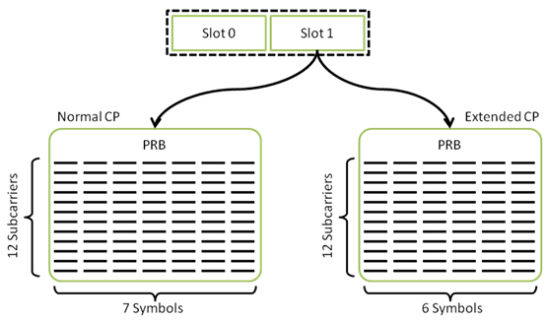 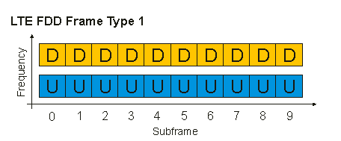

**Type-1**

In FDD mode, uplink and downlink frames are both 10ms long and are separated either in frequency or in time.

For full-duplex FDD, uplink and downlink frames are separated by frequency and are transmitted continuously and synchronously. For half-duplex FDD, the only difference is that a [UE](javascript:void(0);) cannot receive while transmitting.

**Type-2**

In TDD mode, the uplink and downlink subframes are transmitted on the same frequency and are multiplexed in the time domain. The locations of the uplink, downlink, and special subframes are determined by the uplink-downlink configuration.

Special subframes are used for switching from downlink to uplink and contain three sections: [DwPTS](javascript:void(0);), [GP](javascript:void(0);), and [UpPTS](javascript:void(0);).

DwPTS & UpPTS-Downlink & Uplink Pilot Time Slot

GP-Guard Period.

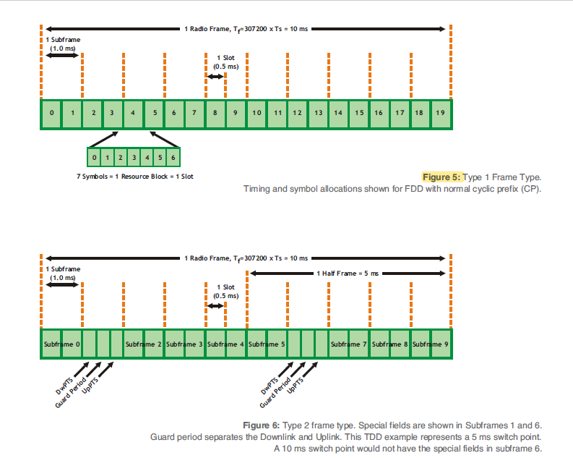

**Resource Block & Resource Element:**

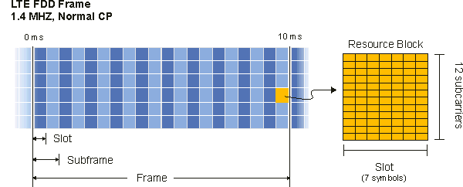Resource block ([RB](javascript:void(0);)) is the smallest unit of resources that can be allocated to a user. The resource block is 180 [kHz](javascript:void(0);) wide in frequency and 1 slot long in time.The number of subcarriers used per resource block for most channels and signals is 12 subcarriers.

**RE(Resource Element):-**

The resource element, which is 1 subcarrier x 1 symbol, is the smallest discrete part of the frame and contains a single complex value representing data from a physical channel or signal.

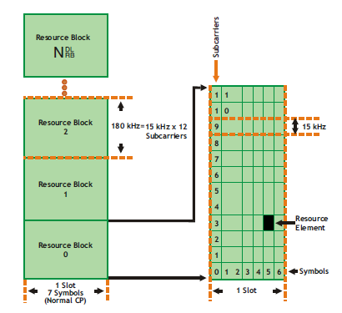 **RB/RE/PRB/Frame Details:-** 

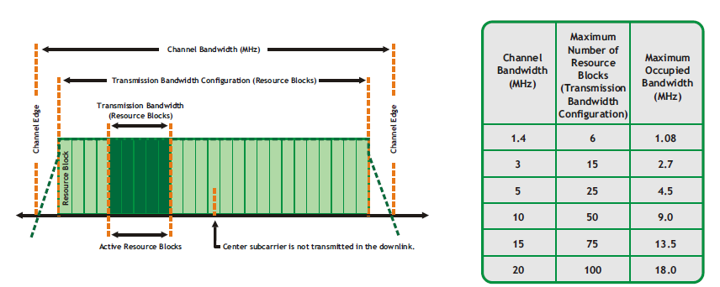

**RSRP/RSRQ/SINR/CQI Definition:-**

**RSRP – Reference Signal Received Power:** RSRP is a RSSI type of measurement, as follows there are some definition of it and some details as well.  
It is the power of the LTE Reference Signals spread over the full bandwidth and narrowband.  
A minimum of -20 dB SINR (of the S-Synch channel) is needed to detect RSRP/RSRQ.

**Range -44…-140 dBm**

***RSRQ – Reference Signal Received Quality:***Quality considering also RSSI and the number of used Resource Blocks (N) RSRQ = (N \* RSRP) / RSSI measured over the same bandwidth. RSRQ is a C/I type of measurement and it indicates the quality of the received reference signal. The RSRQ measurement provides additional information when RSRP is not sufficient to make a reliable handover or cell reselection decision.

**Range- -3 to -19.5 db**

In the procedure of handover, the LTE specification provides the flexibility of using RSRP, RSRQ, or both.

It must to be measured over the same bandwidth:

* Narrowband N = 62 Sub Carriers (6 Resource Blocks)
* Wideband N = full bandwidth (up to 100 Resource Blocks / 20 MHz)

**RSSI – Received Signal Strength Indicator:** The carrier RSSI (Receive Strength Signal Indicator) measures the average total received power observed only in OFDM symbols containing reference symbols for antenna port 0 (i.e., OFDM symbol 0 & 4 in a slot) in the measurement bandwidth over N resource blocks.

The total received power of the carrier RSSI includes the power from co-channel serving & non-serving cells, adjacent channel interference, thermal noise, etc. Total measured over 12-subcarriers including RS from Serving Cell, Traffic in the Serving Cell

**CQI-Channel Quality Indicator:-**

CQI is the information that UE sends to the network and practically it implies the following two

i) Current Communication Channel Quality is this-and-that..

ii) I (UE) wants to get the data with this-and-that transport block size, which in turn can be directly converted into throughput

**0-6(QPSK), 7-9(16QAM), 10-15(64QAM).**

**Layer-3**

**RRC CONNECTION ESTABLISHMENT**

* RRC connection establishment is used to make the transition from RRC Idle mode to RRC Connected mode. UE must make the transition to RRC Connected mode before transferring any application data, or completing any signalling procedures
* The RRC connection establishment procedure is always initiated by the UE but can be triggered by either the UE or the network. For example, the UE triggers RRC connection establishment if the end-user starts an application to browse the internet, or to send an email. Similarly, the UE triggers RRC connection establishment if the UE moves into a new Tracking Area and has to complete the Tracking Area Update signalling procedure. The network triggers the RRC connection establishment procedure by sending a Paging message. This could be used to allow the delivery of an incoming SMS or notification of an incoming voice call
* RRC connection establishment for LTE is relatively simple compared to UMTS. The UMTS procedure requires NBAP and ALCAP signalling across the lub interface between the Node Band RNC. These signalling protocols are used to setup a radio link and new transport connection. The flat network architecture for L TE removes the requirement for these signalling procedures
* In the case of LTE, the initial Non-Access Stratum (NAS) message is transferred as part of the RRC connection establishment procedure. In the case of UMTS, the initial NAS message is transferred after the RRC connection establishment procedure. The approach used by L TE helps to reduce connection establishment delay
* RRC connection establishment configures Signalling Radio Bearer (SRB) 1 and allows subsequent signalling to use the Dedicated Control Channel (DCCH) rather than the Common Control Channel (CCCH) used by SRB 0
* The RRC Connection Request message is sent as part of the Random Access procedure. It corresponds to the initial Layer 3 message. It is transferred using SRB 0 on the Common Control Channel (CCCH) because neither SRB 1 nor a Dedicated Control Channel (DCCH) have been setup at this point. The uplink Resource Block allocation for the RRC Connection Request message is signalled within the Random Access Response message
* The content of the RRC Connection Request message.It includes a UE identity and an establishment cause.

There is no scope for the UE to report any measurements within the RRC Connection Request message.

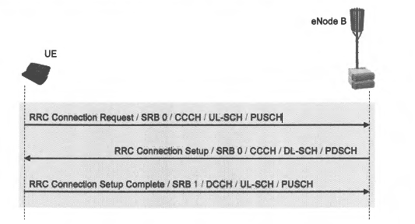

**Signalling for RRC connection establishment:**

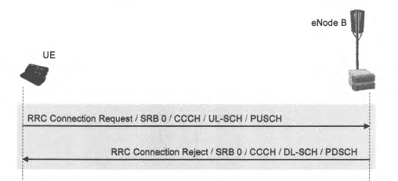

**Signalling for rejected RRC connection establishment:**

***ATTACH* AND DEFAULT BEARER ESTABLISHMENT:**

* The attach procedure is used to register with the Evolved Packet Core (EPC). This allows the subsequent use of packet services within the Evolved Packet System (EPS). The UE can also use the attach procedure to register for non-EPS services, e.g. the speech service based upon CS fallback.
* The attach procedure also involves establishing a default bearer between the UE and PDN Gateway. This provides always-on connectivity for the UE. In addition, the attach procedure can trigger the establishment of dedicated bearers.
* The signaling associated with the attach and default bearer establishment. Some signaling Messages are nested within other messages, e.g. the PDN Connectivity Request message is sent within an Attach Request message, which is sent within an RRC Connection Setup Complete message.

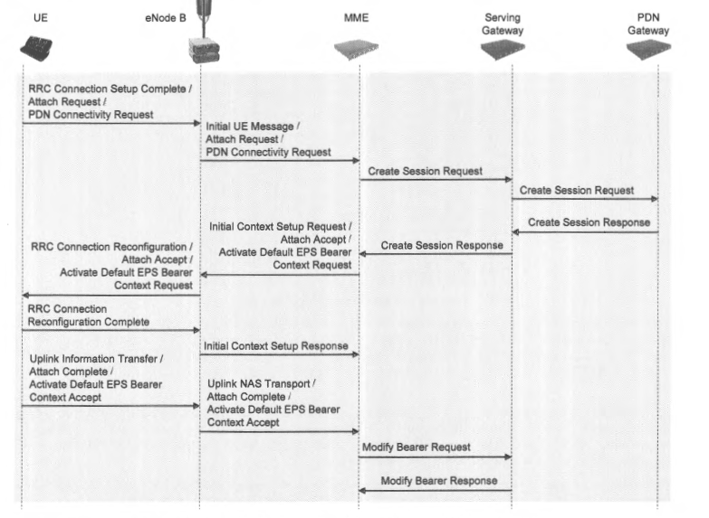

**Signalling for the attach and default bearer establishment procedure:**

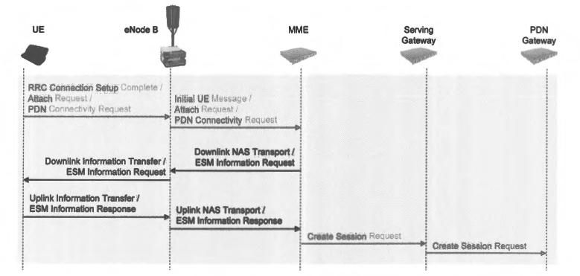

**Additional signalling for the ESM Information Request procedure:**

**DEDICATED BEARER ESTABLISHMENT:**

* A dedicated bearer is required if the end-user requires a different Quality of Service (QoS) to that offered by the default bearer, or if the end-user requires connectivity to a different Packet Data Network (PDN) to that provided by the default bearer. Dedicated bearers are configured to run in parallel to the existing default bearer
* The dedicated bearer establishment procedure is initiated by the network but may be requested by the UE. The UE can request a dedicated bearer by sending a Non-Access Stratum (NAS) Bearer Resource Allocation Request to the MME
* The UE starts the T3480 timer when sending a Bearer Resource Allocation Request message. The message is re-transmitted ifT3480 expires prior to the UE receiving a response from the MME. 3GPP have specified a fixed value of 8 s for the T3480 timer. The Bearer Resource Allocation Request message can be re-transmitted a maximum of 4 times before the overall procedure is aborted.

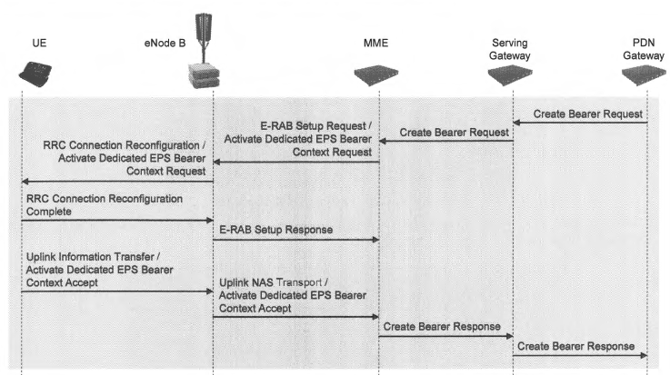

**Signalling for the dedicated bearer establishment procedure:**

**TRACKING AREA UPDATE:-**

* Tracking Area Updates (TAU) become applicable after the UE has completed the Attach procedure and has moved into the EPS Mobility Management (EMM) REGISTERED state. They can be triggered in either RRC Idle mode or RRC Connected mode, but the UE must be in RRC Connected mode to actually complete the procedure

**The TAU procedure is used for:**

1. normal TAU due to mobility, i.e. when the UE enters a tracking area which is not included within the list of tracking areas with which the UE is registered
2. periodic TAU after the T3412 timer expires. The value of T3412 is initialised during the Attach procedure within the Attach Accept message Periodic TAU confirm to the network that the UE is still present
3. registering with the CS domain for non-EPS services when the UE is already attached for EPS services. This involves completing an IMSI attach as part of the TAU procedure.
4. registering with the EPS after an incoming inter-system change, e.g. reselecting the LTE network after being camped on the UMTS network
5. re-registering with the EPS after a CS fallback connection has been completed
6. MME load balancing. The UE initiates a TAU procedure if the eNode B releases its RRC connection using a cause value of 'Load Balancing TAU Required'
7. updating the UE specific DRX cycle. UE are allowed to select their own DRX cycle and signal it to the MME. The selected DRX cycle can be specified within the Tracking Area Update Request message
8. indicating that a UE has selected a Closed Subscriber Group (CSG) cell whose CSG Identity is not included within the UE's allowed CSG list

* The TAU procedure may involve a change of Serving Gateway and/or a change of MME.

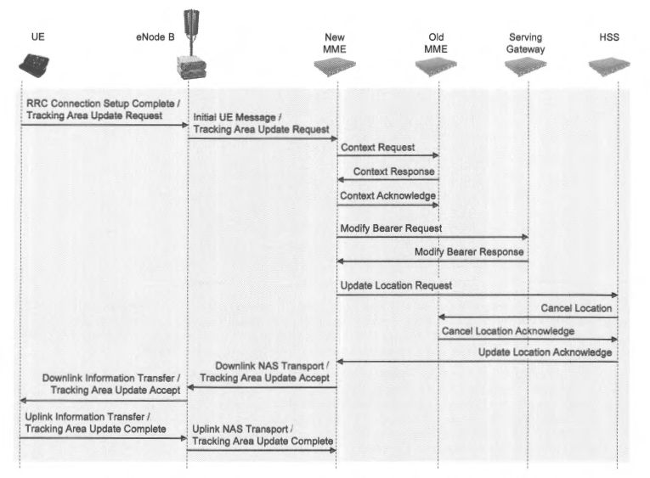

**Signalling for the Tracking Area Update (TAU) procedure (with change of MME):**

**PAGING PROCEDURE:-**

**The paging procedure can be used to:**

1. initiate a mobile terminating PS data connection
2. initiate a mobile terminating SMS connection
3. initiate a mobile terminating CS fallback connection
4. trigger a UE to re-acquire system information
5. provide an Earthquake and Tsunami Warning System (ETWS) notification
6. provide a Commercial Mobile Alert Service (CMAS) notification

* The paging procedure is applicable to UE in both RRC Idle mode and RRC Connected mode. For example, a UE in RRC Idle mode could be paged to initiate a mobile terminating CS fallback connection, while a UE in RRC Connected mode could be paged to signal a CMAS notification
* The paging procedure can be initiated by either the MME or the eN ode B. For example, the MME can use the paging procedure to initiate a mobile terminating PS data connection, while the eN ode B could use the paging procedure to trigger a UE to re-acquire the system information.

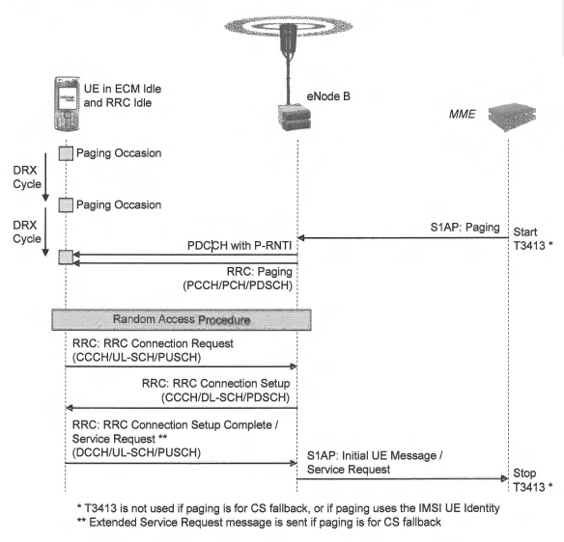**High level Paging procedure initiated by the MME**

**Layer-2**

**Packet Data Convergence Protocol (PDCP)**

In the LTE radio protocol stack, the PDCP layer is located above the RLC layer and below the IP layer (in the user plane) or the RRC layer (in the control plane).

In LTE, the PDCP layer has evolved to support a security function; that is, integrity protection and ciphering. To provide time-varying characteristics to the security function, a PDCP sequence number has been introduced in the PDCP layer. The PDCP sequence number is attached to each PDCP PDU, and it is used to generate different security output per PDCP PDU. Thanks to the PDCP sequence number, the PDCP layer is able to perform ARQ-related functions, which can improve the radio efficiency at handover.

**PDCP Functions and Architecture:-**

Radio bearers utilizing PDCP entities can be categorized into three types:

SRB: Signaling radio bearer using AM RLC

AM DRB: Data radio bearer using AM RLC

UM DRB: Data radio bearer using UM RLC

Depending on the radio bearer characteristics and the mode of the associated RLC entity,

the following functions are selectively performed by the PDCP entity:

\_ header compression using Robust Header Compression (ROHC) for DRB;

\_ security functions:

– integrity protection for SRB;

– ciphering for SRB and DRB;

\_ maintenance of PDCP Sequence Numbers for SRB and DRB;

\_ handover support functions:

– status reporting for AM DRB;

– duplicate elimination of lower layer SDUs for AM DRB;

– in-order delivery of upper layer PDUs for AM DRB;

\_ timer-based SDU discard for SRB and DRB.

**Header Compression:-**

Every IP packet has a few tens of bytes of header, which may be a considerable amount compared with the payload size. For example, in a Voice over IP (VoIP) service where RTP/UDP/IPv6 protocols are used, every packet contains 60 bytes of header while the payload size is typically 20 \_ 30 bytes. Therefore, header compression, a mechanism to reduce the size of header overhead, is essential to improve transmission efficiency, especially for VoIP services.

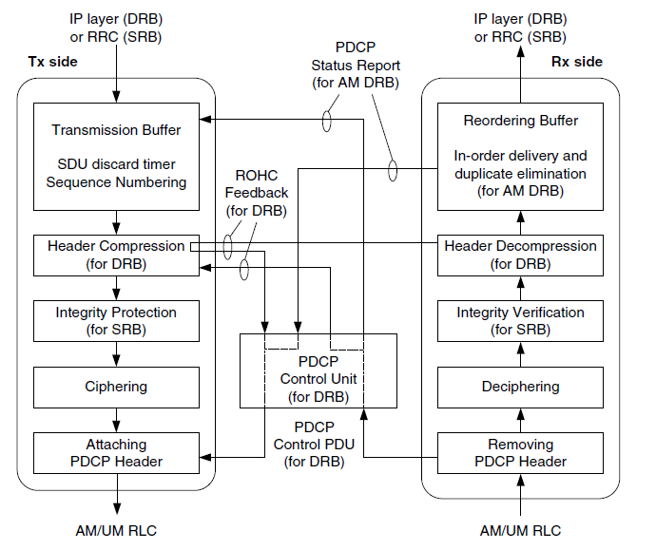

**Functional view of PDCP entity:-**

**Security:-**

The security function includes both integrity protection and ciphering. The configuration of the security function is the responsibility of the RRC, but the responsibility for actually performing the security function falls to the PDCP. When security activation is indicated by the RRC layer, the PDCP layer applies the security function to all PDCP SDUs for the downlink and the uplink.

**Integrity Protection:-**

Integrity protection is used to detect whether the packet has been replaced or inserted by unauthorized parties during delivery. It is realized by a special code, called the Message Authentication Code-Integrity (MAC-I). The MAC-I has a length of 4 bytes

Ciphering .The purpose of ciphering is to maintain the confidentiality of messages between a sender anda receiver. The original message is masked (i.e., XOR operation) by a ciphering keystream,and a third party cannot recover the original message unless it has the same ciphering keystream.The ciphering keystream is the output of the ciphering algorithm

**SDU Discard:**

The SDU discard function is used to prevent buffer overflow in the transmitter. Each SDU can stay in the transmission buffer only for the configured time period in the PDCP entity.

**PDCP PDU Formats**

In PDCP, two types of PDU are defined: PDCP Data PDUs and PDCP Control PDUs. A

PDCP Data PDU is used to transport user plane data such as an IP packet or control plane data such as an RRC message. A PDCP Control PDU is used to transport PDCP control information such as ROHC feedback or a PDCP status report. The PDCP Control PDU is not used for SRBs.

**Radio Link Control (RLC)**

* The RLC layer performs framing of RLC SDUs to put them into the size indicated by the lower MAC layer. The RLC transmitter segments and/or concatenates RLC SDUs to construct RLC PDUs, and the RLC receiver reassembles RLC PDUs to reconstruct RLC SDUs.
* The RLC layer is connected to the lower MAC layer via logical channels. Each logical channel transports different types of traffic, and the name of the logical channel reflects the characteristic of the traffic it transports.
* RRC messages transmitted on the logical channels PCCH, BCCH, and CCCH do not require security protection, and thus go directly to the RLC layer, bypassing the PDCP layer.

Other than those RRC messages, all control plane and user plane traffic goes through the PDCP layer and RLC layer.

* RLC functions are performed by the RLC entity. An RLC entity is established when a radio bearer is set up, and removed when the associated radio bearer is released. When established, the RLC entity is configured in one of three operating modes: Transparent Mode (TM), Unacknowledged Mode (UM), and Acknowledged Mode (AM). Depending on the operating mode, different RLC functions are performed by the RLC entity.

An RLC entity is used for only one radio bearer. However, a bidirectional radio bearer can have two RLC entities, in which case two UM RLC entities with different directions are used for the radio bearer.

**RLC Functions and Architecture:**

1. **Transparent Mode (TM) RLC**

The TM RLC is an operating mode utilized only for the transport of special RRC messages that do not require security protection. RRC messages such as Paging messages transmittedon the PCCH, system information broadcast messages transmitted on the BCCH, and SRB0 messages transmitted on the CCCH do not require security protection, so they bypass the PDCP layer and go directly to the TM RLC. Therefore, the upper layer of the TM RLC is the RRC layer. The radio bearers used for these RRC messages have fixed RB configurations

The TM RLC supports only unidirectional radio bearers. Therefore, a TM RLC entity is

configured either as a transmitting TM RLC entity or a receiving TM RLC entity. In a transmitting.

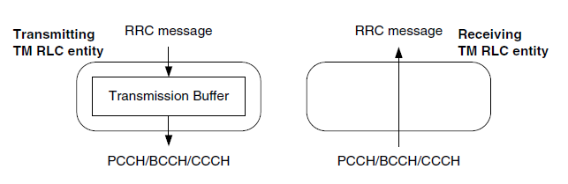

**Functional view of the TM RLC entity:**

TM RLC entity, a transmission buffer is used to store RLC SDUs. The stored RLC SDUs are delivered to the MAC layer only when a transmission opportunity is indicated bythe MAC layer.

**2-Unacknowledged Mode (UM) RLC**

The UM RLC is an operating mode optimized for delay-sensitive user traffic such as VoIP or audio/video streaming. The UM RLC is used only for user plane traffic, so the associated logical channel is only the DTCH. The upper layer of the UM RLC is the PDCP layer. To support the delay-sensitive characteristics, retransmission is not performed in the UM RLC. The side effect of “no retransmission” is that RLC PDUs are subject to loss, but some loss of packets is usually acceptable to delay-sensitive traffic. Since retransmission is not supported, feedback from the receiver is not needed either. The absence of feedback means the transmission result of the RLC PDU is not acknowledged, hence the name “Unacknowledged Mode”.

The UM RLC entity performs a framing function to make RLC SDUs fit into RLC PDUs

whose size is indicated by the lower MAC layer. The framing function comprises segmentation and concatenation in the RLC transmitter, and reassembly in the RLC receiver. To support the framing function, some information related to framing is included in the RLC PDU header.

The PDU header also contains an RLC sequence number that can be used for RLC PDU

identification. Based on the RLC sequence number, the receiving UM RLC entity can perform reordering of the received RLC PDUs. The reordering function is required because RLC PDUs can be received out of sequence due to the use of multiple HARQ processes in the MAC layer. The HARQ reordering is performed in the RLC reception buffer, and it is realized by reordering timer and state variables.

Similar to the TM RLC, a UM RLC entity supports unidirectional radio bearers. Thus, a

UM RLC entity can be configured either as a transmitting entity or as a receiving entity.

However, the UM RLC entity can also support bidirectional radio bearers, in which case, one transmitting entity and one receiving entity are used.

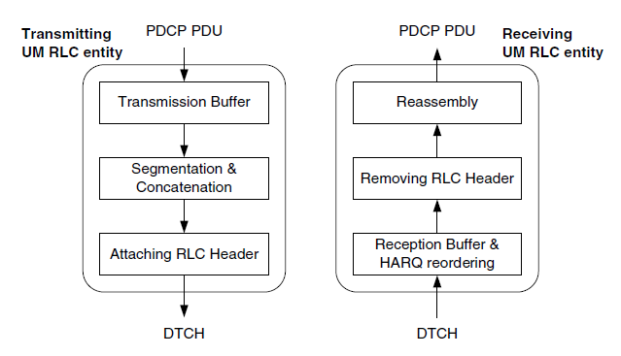

**Functional view of the UM RLC entity:**

**Acknowledged Mode (AM) RLC.**

The key feature of the AM RLC is “retransmission”. The AM RLC guarantees lossless transmissionwith the aid of retransmission. Since the transmission is lossless, the AM RLC isutilized by most of the traffic in both control plane and user plane. In the control plane, allRRC messages other than those using TM RLC utilize the AM RLC. They are transmitted onthe logical channel DCCH. In the user plane, the interactive/background type user trafficTransmission Buffer. such as Web browsing and file transfer utilize the AM RLC. Audio/video streaming may alsoutilize the AM RLC if the delay requirement is not stringent. User plane traffic is transmittedon the logical channel DTCH. For both control plane and user plane, the upper layer of theAM RLC is the PDCP layer.

AM RLC entity performs framing and HARQ reordering similar to the UM RLC entity. In addition, the AM RLC entity performs Automatic Repeat reQuest (ARQ) related functions such as polling, status reporting, retransmission, and re-segmentation. These functions are realized by transmission/reception windows and state variables.

The transmitter performs retransmission based on feedback from the receiver. The feedback is called an “RLC status report”, which is transported by an RLC Control PDU. Therefore, in an AM RLC entity, two types of RLC PDU – RLC Data PDUs and RLC Control PDUs – are used. The two are differentiated by a 1-bit flag (the “D/C” field) in the RLC PDU header. For RLC Data PDUs, the RLC PDU header further includes ARQ-related information, for example, a polling bit and re-segmentation information, in addition to an RLC sequence number and framing-related information.

For transmission in AM RLC, RLC Control PDUs are prioritized over RLC Data PDUs,

and, among the RLC Data PDUs, RLC Data PDUs for retransmission are prioritized over RLC Data PDUs for new transmission.

An AM RLC entity supports bidirectional radio bearers, and is configured with both a transmitting side and a receiving side. The functional view of the AM RLC entity.

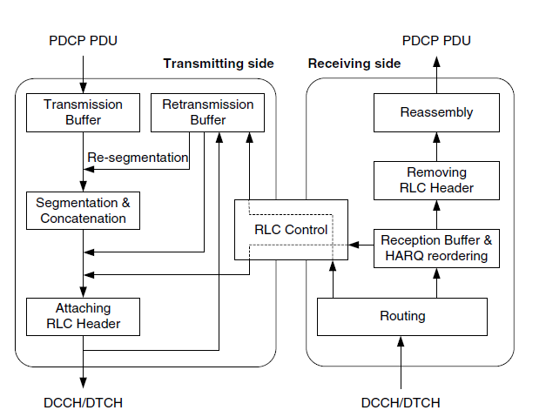

**Functional view of the AM RLC entity:**

**Framing**

The RLC transmitter constructs RLC Data PDUs from RLC SDUs when a transmission

opportunity is indicated by the MAC layer. For UM and AM RLC, the MAC layer also indicates the size of RLC resource allocated to the RLC transmitter. The RLC resource size is decided by the MAC layer on consideration of various aspects such as transmission resource, transmission power, radio condition, QoS of RBs, and so on. The RLC transmitter fills up the indicated size by constructing new RLC Data PDUs, possibly with an RLC Control PDU and RLC Data PDUs for retransmission in the AM RLC case. Typically, the RLC transmitter constructs only one new RLC Data PDU for each transmission opportunity.

Segmentation may be performed at the beginning and at the end of the payload part. To

indicate whether segmentation was actually performed, a 2-bit indicator called “Framing Info (FI)” is included in the PDU header.

If more than one SDU element is concatenated in an RLC Data PDU, the RLC receiver

should know the length of each element to parse the PDU. Therefore, for each SDU element, an 11-bit indicator called the “Length Indicator (LI)” is included in the PDU header to indicate the length in bytes of the corresponding SDU element

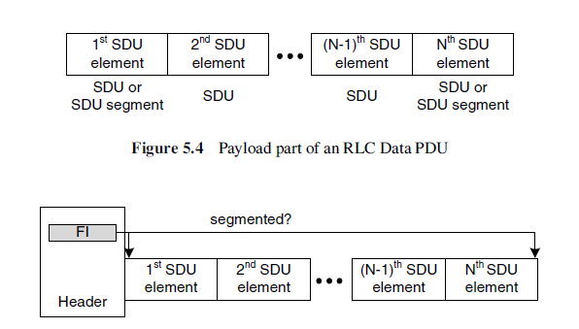

**Framing Info:**

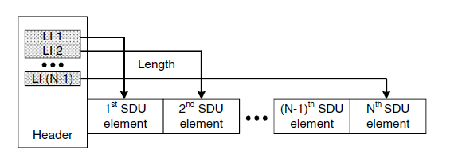

**Length Indicator:**

**Reordering**

Reordering is performed in UM and AM RLC to rearrange the processing order of RLC Data PDUs in sequential order if they are received out of sequence. The out-of-sequence reception of RLC Data PDUs is likely to occur due to the multiple HARQ processes running in parallel with “Stop-And-Wait” operation in the MAC layer. Since out-of-sequence reception is caused by HARQ operation, this function is also called “HARQ reordering”.

The detection of out-of-sequence RLC Data PDUs is based on the RLC Sequence Number (SN) included in the PDU header. The RLC SN uniquely identifies the corresponding RLC Data PDU, with a length of 5 or 10 bits for UM RLC and 10 bits for AM RLC. The RLC receiver detects out-of-sequence PDUs by comparing the RLC SN of the last in-sequence PDU and that of the received PDU. If there is a gap between the two, the RLC receiver decides that the received RLC Data PDU is out of sequence, and stores it in the reception buffer at the position indicated by the RLC SN. The stored PDU is processed only after all the previous missing PDUs are received and processed.

Sometimes HARQ transmission may not succeed for RLC Data PDUs. For example, there may be a HARQ failure – that is, transmission has not succeeded for the maximum number of HARQ retransmissions – or a NACK-to-ACK error – that is, the feedback of NACK by the HARQ process receiver is misinterpreted as ACK by the HARQ process transmitter. In this case, the RLC receiver will not be able to receive the RLC Data PDUs from the HARQ processes, and thus it does not need to wait for them any longer.

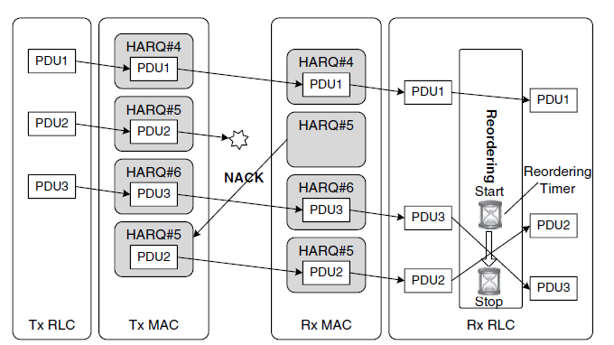

**Out-of-sequence reception and HARQ reordering:**

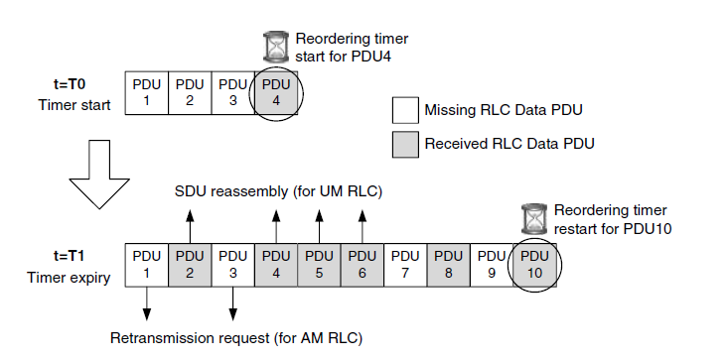

**Example of the HARQ reordering operation:**

**Medium Access Control (MAC)**

Medium Access Control (MAC) layer controls the upper layers’ access to the communication medium, which is the PHY layer. The MAC layer is connected to the PHY layer below through transport channels, and the MAC layer is connected to the RLC layer above through logical channels. Thus, the MAC layer decides which logical channels can access the transport channels at a given time, and performs multiplexing and de-multiplexing of the data between them.

The MAC layer basically provides the radio resource allocation service and the data transfer service to the upper layer. As part of the radio resource allocation service the MAC layer performs procedures such as logical channel prioritization, power headroom reporting, the handling of UL grant and DL assignment, and so on. As part of the data transfer service, the MAC layer performs procedures such as scheduling requests, buffer status reporting, random access, and HARQ.

In addition, the MAC layer handles the Semi-Persistent Scheduling (SPS) procedure and

the Discontinuous Reception (DRX) procedure. The SPS procedure is used to increase the cell capacity for a voice service, and the DRX procedure is used to reduce the power consumption of the UE.

**MAC Functions and Services**

As the layer in charge of controlling radio resource, connecting the RLC layer and the PHY layer, and transferring data, the following functions are supported by the MAC layer:

\_ Connecting the upper layer with the lower layer:

– mapping between the logical channels and the transport channels;

– multiplexing of the MAC SDUs from one or different logical channels onto the transport blocks (TBs) to be delivered to the PHY layer on the transport channels;

– de-multiplexing of the MAC SDUs of one or different logical channels from the transport blocks (TBs) delivered from the PHY layer on the transport channels.

\_ Transferring data:

– scheduling information reporting;

– error correction through HARQ.

**MAC Architecture**

MAC layer is composed of a Hybrid Automatic Repeat request (HARQ) entity, a multiplexing/de-multiplexing entity, a logical channel prioritization entity, and a control entity.

The multiplexing and de-multiplexing entity is in charge of composing and decomposing the MAC PDUs and performs (de-)multiplexing of data from several logical channelsinto/from one transport channel.

The HARQ entity performs the transmit HARQ operation and the receive HARQ operation.

The transmit HARQ operation includes transmission of transport blocks and, if necessary, retransmission of the transport blocks, and, if configured, reception and processing of HARQ ACK/NACK signaling. The receive HARQ operation includes reception of transport.

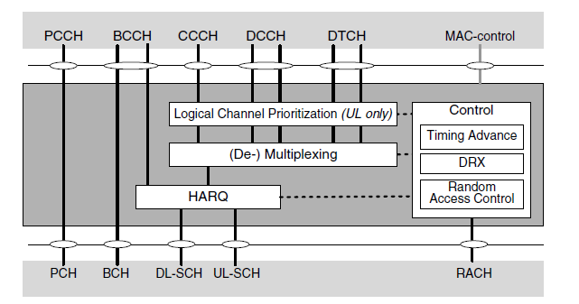

**MAC architecture:**

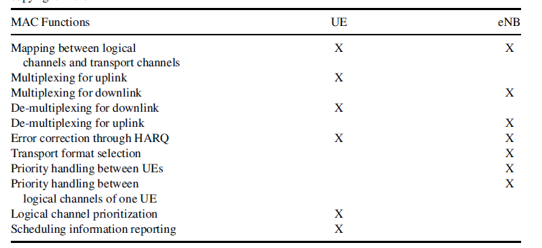

**MAC functions by UE and eNB:**

Controlling radio resource:

– priority handling between UEs by means of dynamic scheduling;

– priority handling between the logical channels of one UE;

– transport format selection.

**Transport Channels**

**There are three types of downlink transport channel:**

**Broadcast Channel (BCH):**This transport channel is used to transport the parts of the

system information that are essential for the UE to operate properly within the network. The transport format for this transport channel is fixed, and the amount of information that can be delivered over this channel is limited.

**Downlink Shared Channel (DL-SCH):**This transport channel is used to transport user

data or control information in the downlink, and the radio resources allocated for this channel can be changed dynamically. In addition to user data and control information, this transport channel transports the remaining system information that is not transported via the BCH.

**Paging Channel (PCH):**This channel is used to transport paging information to UEs to

inform them of an incoming call. This channel is also used to inform UEs about updates to system information and updates to Public Warning System (PWS) messages.

**There are two types of uplink transport channel:**

**Uplink Shared Channel (UL-SCH):**This transport channel is used to transport user data or control information in the uplink. The radio resources allocated for this channel can be changed dynamically.

**Random Access Channel (RACH):**This transport channel is used to transmit the random access preamble when the UE does not have any allocated uplink transmission resource for the transmission of available data, or when the UE is ordered to perform the Random Access procedure by the eNB. Information about the random access preamble is transported over this transport channel.

**Logical Channels**

**There are four types of control logical channel:**

**Broadcast Control Channel (BCCH):**This logical channel is used in the downlink to

broadcast system information and PWS messages. This logical channel is connected to a

Transparent Mode (TM) RLC entity.

**Paging Control Channel (PCCH):**This logical channel is used in the downlink to notify

the UE of an incoming call or a change in system information. This logical channel is

connected to a TM RLC entity.

**Common Control Channel (CCCH):**This logical channel is used to deliver control

information both in the uplink and in the downlink when the sender or the recipient of the information cannot be identified uniquely in layers lower than the RRC layer. This logical channel is connected to a TM RLC entity.

**Dedicated Control Channel (DCCH):**This logical channel is used to deliver dedicated

control information in both the uplink and downlink for a specific UE which has an RRC connection with the eNB. This logical channel is connected to an Acknowledged Mode (AM) RLC entity.

**There is only one type of traffic logical channel:**

**Dedicated Traffic Channel (DTCH):**This logical channel is used to transmit dedicated

user data in both the uplink and downlink. This logical channel is connected either to an Unacknowledged Mode (UM) RLC entity or an AM RLC entity.

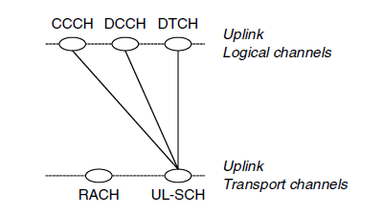

**Mapping between UL channels.**

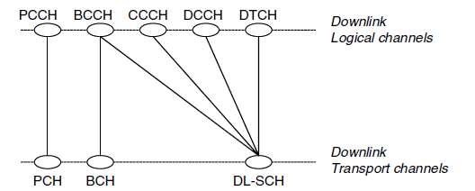

**Mapping between DL channels:**

**Channel Mapping:**

MAC layer is in charge of connecting the transport channels and the logical channels. Among all possible combinations between the logical channels and the transport channels, only a few selected combinations are allowed.

**Scheduling**

To use the limited radio resource efficiently among multiple UEs, radio resources should be managed carefully so that the radio resources are allocated to UEs only when necessary. Thus, in LTE where Orthogonal Frequency Division Multiple Access (OFDMA) is used, the radio resources are shared dynamically among multiple UEs. Radio resource allocation among the UEs and among the radio bearers is decided and coordinated by the eNB. Tomake an optimal allocation, the eNB should be aware of accurate information regarding the data generated in the UEs and the data to be delivered to the UEs.

**Dynamic Scheduling**

The dynamic scheduling method mentioned above requires transmission of resource allocation information whenever data are transmitted between the eNB and the UE. For services such as Voice over IP (VoIP), where packets of small size are periodically generated, dynamic scheduling generates a lot of signaling overhead. To reduce this overhead, Semi- Persistent Scheduling (SPS), where the radio resource can be semi-statically allocated to UEs, is also used in LTE to increase the voice service capacity in a cell. Finally, to satisfy different users’ different needs, the eNB considers the Quality of Service.(QoS) requirements of each configured radio bearer to make a decision on the radio resource allocation.

**Semi-Persistent Scheduling (SPS)**

As mentioned above, a VoIP service periodically generates many small-sized packets at short intervals. If dynamic scheduling is used for a VoIP service, a lot of the downlink assignment and the uplink grant will also be used, leading to a heavy load on the PDCCH. Because the capacity of the PDCCH is limited, reducing the number of the downlink assignment and the uplink grant is required to increase the number of supportable simultaneous VoIP calls in a cell. Thus, SPS is used to allocate radio resources for a long time period with a minimized load on the PDCCH. Typically, SPS is used for predictable services where similar-sized data packets are generated periodically.

**Buffer Status Reporting (BSR)**

In LTE, the allocated radio resources for the different UEs are orthogonal in time and frequency. Therefore, if the uplink radio resource is allocated by the eNB to a specific UE but is not used by that UE, the allocated radio resource is just wasted because other UEs cannot use it. Thus, to maximize the use of radio resource, the eNB takes full control of it. When a UE wants to transmit some data in the uplink, it needs to request allocation of radio resource from the eNB, except when it transmits the random access preamble.

To assist the eNB’s optimal allocation of uplink radio resources to a UE, a Buffer Status Report (BSR) is transmitted from the UE to the eNB. The BSR indicates how much data are buffered in the UE’s memory. The BSR is only meaningful in the uplink because for the downlink the eNB knows the buffer status due to the collocation of the eNB’s scheduler and the downlink buffer. Thus, for uplink radio resource allocation, a UE needs to send the BSR to the eNB to indicate the amount of data in the UE that need to be transmitted.

Two formats are defined for the BSR: Long BSR and Short BSR. As can be inferred from

the names, the Long BSR is longer than the Short BSR and is used to deliver buffer status information for the four Logical Channel Groups (LCGs). The Short BSR is used to deliver buffer status information for only one LCG. Which BSR format is used depends on what triggers the BSR, how many LCGs have data to send, and how much space is available in the MAC PDU.

The above states that the amount of data is indicated not per logical channel but per LCG.

A BSR can be triggered in any of the following situations:

When data arrive for a logical channel which has higher priority than the logical channels whose buffers are not empty. In this case, the triggered BSR is called a Regular BSR.

When data become available for the UE’s buffer, which is empty. This is also called a

Regular BSR.If the UE does not inform the eNB of the arrival of new data, there is no

way that the eNB can decide to allocate radio resource to the UE.

When the retxBSR-Timer expires and there is still data in the UE’s buffer. This is also

called a Regular BSR.

When a periodicBSR-Timer expires. This BSR is called a Periodic BSR. This is used for

the UE periodically to deliver updated buffer status information to the eNB.

Thus, to prevent the discarding of data in a logical channel, a BSR is transmitted periodically using the periodic BSR-Timer.

When the remaining space in a MAC PDU can accommodate a BSR. This is called a Padding BSR.

One special type of BSR is the Truncated BSR. The Truncated BSR has the same format

as the Short BSR but with a different LCID field. The Truncated BSR is used when a Padding BSR is triggered and the space in the MAC PDU is not enough to include a Long BSR but when more than one LCG has data in the buffer. From the UE’s perspective, there is not so much difference between a Short BSR and a Truncated BSR

**Scheduling Request (SR)**

The SR procedure is used by the UE to request radio resource for a new uplink transmission. The SR procedure starts when a Regular BSR is triggered but uplink radio resource to transmit. the BSR is not available in the UE. During the SR procedure, the UE performs either transmission of the SR over the PUCCH or initiates the Random Access (RA) procedure, depending on whether the UE is configured with the PUCCH resource for SR or not. The RA procedure is initiated only when the PUCCH resource for SR is not configured. Performing the RA procedure during the SR procedure is not beneficial, in that it takes quite a long time for the UE to obtain uplink resource. Since the RA procedure is subject to collision, the time spent getting uplink resource may be unnecessarily long. Therefore, from a resource allocation delay point of view, it is good to allocate the PUCCH resource for SR

**Power Headroom Report (PHR**)

Unlike the eNB, which is fixed in location and always plugged into the power outlet, the UE is assumed to be moving constantly and thus limited in power. With a given maximum power, if the UE is allocated more resources than it can support, the decoding error rate at the eNB will increase. Thus, it is important that the eNB has an accurate power status for the UE and allocates a suitable amount of radio resource. The Power Headroom Report (PHR) is used to provide the eNB with information about the difference between the nominal maximum transmit power and the estimated required power for uplink transmission. RRC signaling is used to deliver the configuration parameters for the periodic PHR-Timer, the prohibit PHR-Timer, and the dl-Pathloss Change. The periodic PHR-Timer is used to make the UE periodically transmit a PHR. The prohibit HR-Timer is used to prevent frequent transmission of PHRs. When the pathloss fluctuates dramatically, the short-term changes in pathloss are filtered out by the prohibitPHR-Timer. The dl-Pathloss Change parameter is used as a criterion to trigger a PHR. When the measured downlink pathloss is larger than this parameter, a PHR is triggered by the UE.

**Logical Channel Prioritization (LCP)**

The finite radio resource should be allocated and used carefully among the UEs and radio bearers. In the downlink, the eNB is the focal point through which all downlink data flows before being transmitted over the radio interface to each UE. Thus, the eNB can make consistent decisions about which downlink data should be transmitted first. However, in the uplink, each UE makes an individual decision based only on the data in its own buffers and the allocated radio resource. To ensure that each UE makes the best and most consistent decisions in terms of using the allocated radio resource, the Logical Channel Prioritization (LCP) procedure is introduced. The LCP procedure is used for MAC PDU construction by 130 Radio Protocols for LTE and LTE-Advanced

deciding the amount of data from each logical channel and the type of MAC Control Element that should be included in the MAC PDU. By using the LCP procedure, the UE can satisfy the QoS of each radio bearer in the best and most predictable way.

**Discontinuous Reception (DRX)**

Battery saving is the most important issue in mobile communication. To reduce the battery consumption in the UE, a mechanism to minimize the time that the UE spends monitoring the PDCCH is used; this is called the Discontinuous Reception (DRX) functionality. In LTE, up to two different lengths of DRX cycle – that is, long DRX cycle and short DRX cycle – can be used for a UE in RRC\_CONNECTED. Note that the use of short DRX cycle is optionally configured by the eNB.

A long DRX cycle is beneficial for lengthening the UE’s battery life. For example, in the

scenario where a user is using aWeb-browsing service, it may be a waste of UE battery if the UE has to monitor the downlink channel continuously while the user is reading a downloaded Web page. In this case, by using a long DRX cycle, the UE can minimize the time used for monitoring the downlink channel.

On the other hand, a shorter DRX cycle is better when data transfer is resumed quickly. In a packet-switched network, some user packets may arrive at the eNB significantly later than other chunks of the user packets. In this case, if the UE is put into a long DRX cycle before the arrival of the late user packets, the late user packets will be delivered to the UE at the next wake-up time of the long DRX cycle. Because these user packets have already experienced a long delay before the arrival at eNB, the additional delay of a long DRX cycle will badly impact the QoS. Thus, to prevent the UE from entering a long DRX cycle too early, the UE is put into a short DRX cycle. If user packets arrive at the eNB while the UE is using the short DRX cycle, the UE is put back into continuous reception mode by the downlink assignment at the next wake-up time of the short DRX cycle. However, if no more user packets arrive during the short DRX cycle, the UE is put into a long DRX cycle, on the assumption that the packet transfer activity has finished.

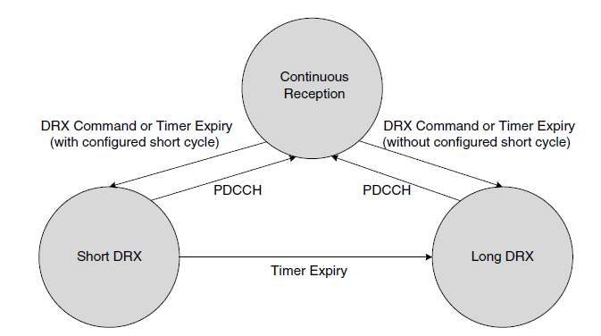

**State transitions for DRX**

**Hybrid-ARQ (HARQ)**

Due to the innate adverse condition of the radio channel, what a sender has transmitted is usually not what a receiver has received. To overcome this obstacle, the receiver should be able to detect whether it has received everything correctly or not. In addition, the sender should be able to make another transmission if there is something wrong. A communication method using the above two elements is called Automatic Repeat reQuest (ARQ). However, if a receiver can perform recovery and correction on its own, this will improve transmission efficiency. This capability is called Forward Error Correction (FEC). ARQ combined with FEC is called Hybrid-ARQ (HARQ).

In LTE, HARQ with soft combining is used In this approach, when a coded bit block for a data unit is received, the receiving side tries to decode the received coded bit block. If the decoding is successful, the recovered data unit is forwarded to the upper layer. However, if the decoding is unsuccessful, the receiving side informs the transmitting side of the decoding failure and the transmitting side makes another transmission for the data unit. Then, the first received coded bit block and the subsequently received coded bit block are combined and decoded to recover the original data unit. Though each received coded bit block is not enough to recover the original data unit independently, sometimes it is possible to recover the original data unit if multiple coded bit blocks are combined for decoding.

In LTE, the N-channel Stop-And-Wait (SAW) method is also adopted. The SAWoperation means that upon the transmission of a data unit, the transmitting side stops further transmissions until feedback is received from the receiving side. When a HARQ NACK is received, the transmitting side retransmits the previous data unit. However, due to propagation delay over the radio interface and processing delay on both the transmitting and receiving sides, there is a time period during which no transmission is made by the transmitting side. To use the radio resource efficiently and to increase the data rate, it is essential to minimize this time period. Therefore, multiple independent HARQ processes are interlaced in time so that all transmission time resources can be used by at least one of the HARQ processes. Each HARQ process is responsible for a separate SAWoperation and manages a separate decoding buffer.

The reason why ARQ or HARQ is used is that the error may occur during transmission

and reception. Due to noise in the channel, what has been transmitted by the transmitter is sometimes corrupted over the radio interface. By using ACK or NACK, the transmitting side should know whether its transmission was received successfully by the receiving side. However, ACK and NACK are transmitted over the same medium that the data travel through.

**TTI Bundling**

Due to the use of a finite battery and the limited capacity of power amplifiers, there is a limit in the uplink transmission power of the UE. Thus, when the UE is located near to the cell edge, even a small packet such as VoIP may not be transmittable in a single subframe. In other words, compared to transmission by a UE located in the center of a cell, the UE at the cell edge needs more energy per subframe to achieve the same bit error rate. If the UE cannot increase its transmission power, the UE should alternatively lengthen the transmission time to increase the effective energy per bit. In the end, this can be regarded as decreasing the effective amount of data per subframe.

**Measurement Gap**

Because the UE is moving around, the cell to which the UE is connected should be changed according to the location of the UE and the quality of the radio signal. Although the eNB can measure the quality of the radio signal transmitted by the UE, it cannot measure the quality of the radio signal received by the UE. Thus, to make an accurate decision regarding when to change the serving cell and to which cell the UE should be connected, the UE should measure the downlink signal of the cells and should report the result to the eNB.

Normally, the UE can perform measurement of cells of the same frequency that the UE is using and it can measure cells of frequencies other than the frequency that the UE is camping on while it is in RRC\_IDLE. But when the UE is transmitting and receiving user data in RRC\_CONNECTED, it may not have time to measure other frequencies or other Radio Access Technology (RAT).

**MAC PDU Formats**

The MAC Protocol Data Unit (PDU) is a data block unit that is exchanged between the MAC layer and the PHY layer. As a result of multiplexing, the MAC PDU is composed using MAC CEs and MAC Service Data Units (SDUs), and delivered to the PHY layer. Because most CPUs available in the market process data in units of multiples of eight bits, the size of the MAC PDU, the MAC SDU, the MAC CE, and the MAC subheader is set as a multiple of eight bits.

MAC PDU consists primarily of the MAC header and the MAC payload. The MAC header is further composed of MAC subheaders, while the MAC payload is composed of MAC CEs, MAC SDUs, and padding. Typically, each subheader corresponds to either one MAC CE or one MAC SDU or padding.

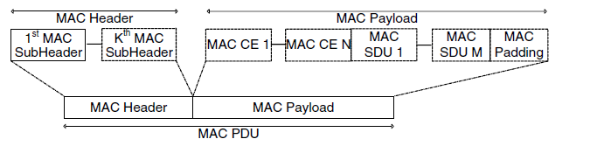

**Format of a MAC PDU.**

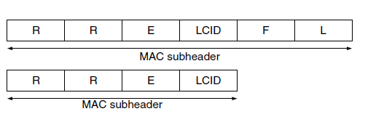

The F field indicates the size of the L field. There are two sizes of the L field: either 7 bits or 15 bits.

The L field indicates the size of the related MAC SDU or the related MAC CE. The size of the L field used depends on whether the size of the corresponding MAC SDU is less than 128 bytes or not.

For the last subheader in the MAC PDU, the L field and the F field are omitted because the size of the last part of the MAC payload can be calculated automatically using the size of the MAC PDU and the size of the other elements in the MAC PDU. In addition, for a MAC CE of fixed size, the L field and the F field are omitted in the corresponding MAC subheader.

The E field indicates whether this subheader is the last subheader or not in the MAC PDU**.** The first is used for a MAC SDU that is not the last element in a MAC PDU or for a flexible-size MAC CE. The second is used for a MAC SDU that is the last element in the MAC PDU or for a fixedsize MAC CE.

When a MAC PDU is used to transport user data from the PCCH or the BCCH logical channels, the MAC PDU includes data from only one logical channel. Because multiplexing is not applied in a MAC PDU for data of logical channels, there is no need to include the LCID field in the MAC header.

**Buffer Status Report MAC CE:**Information regarding how much data is accumulated in the UE’s buffer is delivered from the UE to the eNB using this MAC CE. Three LCID

values are used to differentiate between a Short BSR, a Long BSR, and a Truncated BSR.

The LCG group field in the BSR MAC CE indicates one of the four LCGs to which the

following Buffer Size field corresponds. The Buffer Size field actually indicates

the amount of data accumulated in the buffer of the concerned LCG. The Short BSR and

the Truncated BSR include the buffer status for one LCG, and the Long BSR includes the

buffer status for all four LCGs.

**Power Headroom MAC CE:**Available power headroom information is reported from the bUE to the eNB using this MAC CE.

**DRX Command MAC CE:**This MAC CE is transmitted from the eNB to the UE and used to put the UE into a DRX cycle to save the UE’s battery. This MAC CE includes only a MAC subheader, and the size of this MAC CE is fixed.

**Timing Advance Command MAC CE:**This MAC CE is delivered from the eNB to the

UE and informs the UE of the amount of timing adjustment that the UE has to apply for

uplink timing alignment. The size of this MAC CE is fixed.

**C-RNTI MAC CE:**This MAC CE is transmitted from the UE to the eNB and includes the UE’s C-RNTI for the purpose of contention resolution during the RA procedure. It is used only when the UE has a valid C-RNTI. The size of this MAC CE is fixed.

**UE Contention Resolution Identity MAC CE:**This MAC CE is sent from the eNB to the

UE and is used for the purpose of contention resolution during the RA procedure. It is used only when the UE does not have a valid C-RNTI. When the UE sends a CCCH SDU during the RA procedure, the eNB includes exactly the same CCCH SDU in this MAC Control.

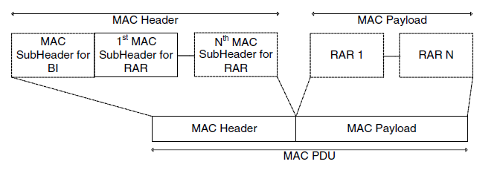

**Format of MAC PDU for the RA response:**

**Important Link for Details:-**

**1-Protocol Conformance**

<http://www.sharetechnote.com/html/LTE_Protocol_CT.html>

**2-PowerOn Procedure:-**

http://www.cs.nccu.edu.tw/~jang/teaching/NextMobCom\_files/Power-On%20and%20Power-Off%20Procedures.pdf

**3-OverAll LTE Sequence:-**

<http://www.sharetechnote.com/html/BasicProcedures_LTE.html>

**4-Channels:-**

<http://www.rfwireless-world.com/Tutorials/LTE-logical-transport-physical-channels.html>5-DCI Formats in LTE:

# <https://ltebasics.wordpress.com/2013/09/24/different-dci-formats-in-lte/>

# 6-measurment Report & Measurment Gap:-

# [http://www.sharetechnote.com/html/Handbook\_LTE\_MultiCell\_Measurement\_LTE.html#LTE\_Measurement\_Report\_Trigger](http://www.sharetechnote.com/html/Handbook_LTE_MultiCell_Measurement_LTE.html" \l "LTE_Measurement_Report_Trigger)

# 7-RACH Procedure:

# [http://www.sharetechnote.com/html/RACH\_LTE.html#Why\_RACH](http://www.sharetechnote.com/html/RACH_LTE.html" \l "Why_RACH)

# 8-CSFB/SRVCC/IMS: <http://www.telecomhall.com/what-is-csfb-and-srvcc-in-lte.aspx>

**END**